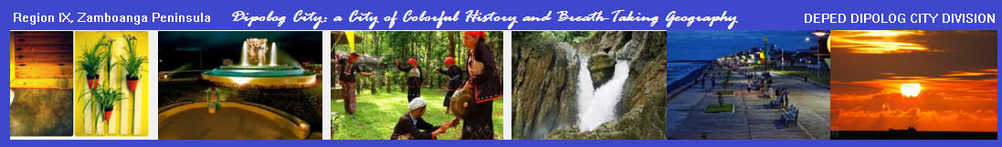

**THE FOUNDING HISTORY OF DEPED DIPOLOG CITY DIVISION**

D

ipolog City Division has a colorful history which spans over four decades now since its inception in 1975. It has seen the ups and downs of the city from a mere ordinary chartered city in 1969 into what it is now today – a leading business hub and a vibrant city – in the entire province of Zamboanga del Norte.

Understanding the history of the City Division won’t be that crystal clear without looking back at how the city struggled to become an independent city. The following significant information were painstakingly researched starting from an interview with Mrs. Narcisa M. Ortega, a retired Education Supervisor-I on the actual date of conception of the City Division as well as with the City Information and Planning offices to come up with a comprehensive storyline about how our beloved Dipolog City was created. Internet Websites were equally helpful, too.

**Earliest Recorded History**

Originally, the whole Dipolog town site where it is now today was first located at Sitio Tulwanan. In the 14th century, Tulwanan was established 6 kilometers inland, adjoining the river near the present day *barangay* center of *Lugdungan*.

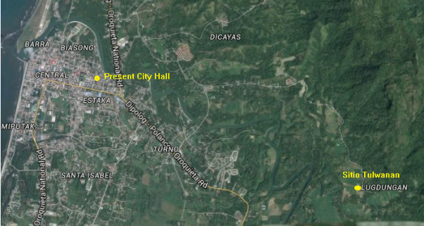

The Old Sitio Tulwanan was located in what is now Barangay Lugdungan.

In 1834, a Civil Government was organized by the Spanish Provincial Government of Misamis under whose jurisdiction Dipolog belonged. It was first led by a town executive named Don Domingo Ruiz. Since Dapitan District which included Dipolog and neighboring township was far from Cagayan de Oro in Misamis Province, Judge William H. Taft, President of the Second Philippine Commission, decreed to separate the District in 1903.

The following year, on March 04, 1904, Dipolog was converted into a Barangay of Dapitan while Isidro Patangan, then Presidente Local and the American Provincial Secretary of the Provincia Mora visited Dapitan. They delivered a written order that effective immediately, Dipolog would be converted into Barangay of Dapitan to be represented only by two councilors with two policemen to maintain peace and order. People filed protests and petitions against the order to no avail.

The dream of Dipolognons did not stop at this very historic development; they still wished more than just a barangay – to become a municipality! So a number of prominent men lead by Isabelo Echavez and Eleuterio Barinaga assumed this responsibility. They began soliciting construction materials, money and free labor. The town hall was immediately constructed at a cost of P3, 000.00. The construction of the town hall within six months was the only requirement solicited by Gen. John J. Pershing before Dipolog could be converted into a full-fledged township. The first big round Molave post was erected right on the spot where the present city hall now stands.

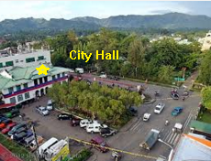

The original site of the first Dipolog Town Hall where Gen. Pershing announced its township. The structure was patterned after the municipal building of Maribojoc, Bohol.

On July 1, 1913, amid solemn inspiring ceremonies, Gen. Pershing announced the township of Dipolog from the balcony of the Town Hall. On the same occasion, the General appointed Pascual T. Martinez as the first Municipal President.

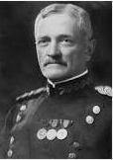

Gen. John J. Pershing

Since then all hopes to become a full-fledged city remained a dream only. Worse, these hopes were sidelined when World War II broke out. But on June 6, 1952, hopes were rekindled again soaring high across the halls of Congress. Through then Congressman Roseller T. Lim, a bill was passed which was approved as Republic Act 711 creating the province of Zamboanga del Norte with Dipolog as the capital town and Zamboanga del Sur with Pagadian as the capital town. Now, Dipolog was already one step away to becoming a full-fledged city.

A decade later, new development about the people’s aspiration resonated again in the halls of Congress. When Engineer Felicisimo L. Herrera was elected Municipal Mayor of Dipolog in 1963 he carried the aspiration of the people to make Dipolog a city. So, on June 21, 1969, through Congressman Alberto Q. Ubay, President Ferdinand E. Marcos signed into law Republic Act 5520 making Dipolog a chartered city effective January 1, 1970. The signing in June 1969, coincided with the launching of Apollo 11 which carried the first men on the moon. This is the reason why there is a rocketship at the center of Dipolog’s Logo. The First City Mayor then was Engineer Felicisimo L. Herrera.

The official logo of Dipolog City

Today, Dipolog has developed into a vibrant city, not only as the seat of government of the Province of Zamboanga del Norte but a hub for commerce and sports. The administration of the present City Mayor Evelyn T. Uy is steering the destiny of the city towards a vision to become a trading hub of Northwestern Mindanao.

**Why Dipolog?**

The word “Dipolog” was believed to have been originated from a misheard name “Dipag” given by a Subanen when the Spanish Recollect Missionary together with his muchacho Antonio Subido asked him for the direction of the old town Tulwanan which was located just across the river. Since then, the name was corrupted by mispronunciation of Visayan and Subano words to “Dipolog”.

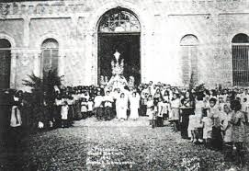

The old Dipolog Cathedral

**The Orchid City**

Many wondered why Dipolog City is now officially called “The Orchid City”. It is not because the city is surrounded with beautiful orchids but these flowers were so common on special occasions like graduations where a bouquet or corsage of orchids were usually offered or donned to loved ones or VIPs. So when a contest was held to give Dipolog City its official identity or tagline, “The Orchid City” penned by Mrs. Victoria A. Jiminez from the former Department of Education, Culture and Sports (DECS) was the official winner. This orchid is the native “Pangadlaw”.



The native “Pangadlaw” orchid

**EDUCATION**

Today, Dipolog City is the educational center of Zamboanga del Norte and is also considered one of the educational centers of Northwestern Mindanao and the Sub-Convention Center of Region IX. In general, the Dipolog City DEPED Division has been known as one of the most performing Divisions in Region IX since its conception in 1975 up to now. But when was the City Division exactly created?

**Brief History**

Indeed, this simple question has no ready answer. So a research team headed by Education Program Supervisor for School Governance and Operations Division (SGOD) Mr. Pergentino S. Yabres was created on April 28, 2016 just for this purpose. The following were the findings of the research team:

* **December 31, 1975** – Creation of Dipolog City Schools Division which was then under the Zamboanga del Norte Provincial Schools Division jurisdiction (p.14).

Before there was Dipolog City Division, all public educational institutions and operations in Dipolog City were under the jurisdiction of then Zamboanga del Norte Provincial Schools Division. Unfortunately, the team could not locate the original document which created the City Division on December 31, 1975. It was only mentioned as one of the highlights in the 80th Adlaw sa Dipolog Report (p. 14) published on July 1, 1993. This is the nearest source as to its exact date of creation. However, if the service records of the resource person, Mrs. Narcisa M. Ortega is the basis, the change started on July 1, 1974. This date appeared to be the transition date when it separated from the jurisdiction of Zamboanga del Norte Provincial Schools Division but its official effectivity was on December 31, 1975.

**City Schools Division Superintendents**

The City Division has been steered by eleven visionary leaders through its forty-year history, namely:

1974-1976: Felipe Mojares (OIC)

1976-1986: Hadji Jawali H. Laja

1986-1991: Angeles A. Alano, Ph.D

1991-1993: Luzminda A. Duque

1993-1996: Avelina E. Eguia, Ed.D

1996-1999: Sharif Adzhar H. Sarahadil, CESO V

1999-2002: Manuel M. Muyargas, CESO V

2002-2003: Antonio Pe. Rimando, Ed.D

2003-2006: Walter O. Albos, CESO V

2005-2012: Teresita E. Cascolan, CESO V

2012-July 2017: Victorina G. Perez, CEO VI

July 1 –Present : Ma. Liza R. Tabilon CESO VI

**Official Logo**

The City Division does not have its own official logo since its conception. On March 3, 2016, Mr. Jose Mari M. Apilan, the Information Technology Officer III, presented several designs to SDS Victorina G. Perez, CEO VI and finally one of the designs was officially chosen. What it stands for:



1. **Laurel** (47 leaves): Sign of excellence; represent the number of schools under the City Division;

2. **Book** (4 open sheets): Free education; open and caring to all Filipino pupils; represent the four districts in the City Division;

3. **1975**: Official creation of the City Division.

**Present Location**

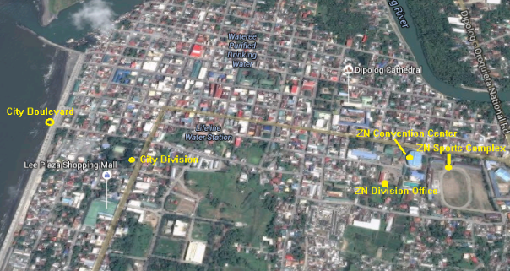

Map of City Division courtesy of Google Maps

**First Major Awards**

Though the City Division was still at its infancy, it had reaped a number of sterling accolades, to state a few:

* 1978 – Eric Gepitulan then a pupil from the Dipolog Pilot Demonstration School was declared the national winner in the 1978 Science Fair Competition
* 1980 – Carina E. Go, then a pupil from the Dipolog Pilot Demonstration School became the National Champion and later on an Asian Champion in the Math Quiz Bee Competition
* February 18-22, 1985 – Dipolog City served host to the 42nd National Secondary Schools Press Conference participated in by around 1,150 delegates (students, advisers, supervisors and principals) from the 13 regions of the country
* 1979 – NAMCYA 1st Runner-Up (National Level)
* 1979 – Population Quiz Show Champion
* 1988 – Science Quiz Bee Champion (National Level)
* 1994 – Outstanding Campus Journalist (National Level)
* 1995 – Palarong Pambansa Sepak-Takraw Champion   
  (National Level)
* 1995 – Palarong Pambansa Basketball Champion (National Level)
* 1977-1992 – NAMCYA Champion for 15 consecutive years (Regional Level)
* Caltex Science Quiz Champion (Regional Level)
* Super Quiz Bee Champion (Regional Level)
* Rizal Oratorical Contest Champion (Regional Level)
* Damath Competition First (Regional Level)
* Science Math, Philippine History and Culture  Quiz Bee Champion (Regional Level)
* Constant recipient of scholarship grants to teachers of long and short-term courses sponsored by the different sponsoring agencies both national and international (a total of 9 teachers from year 1995 up to 1997)
* Constant passers of Philippine Science High School Scholarship Examination since 1972 up to present (a total of 89 Grade 6 pupils)
* Project "KALAMBOAN" (a strategy in  achieving quality education) of DECS Dipolog City Division was a chosen as one of the best practices or winning strategies in enhancing teaching techniques and delivery of instruction in the whole Philippines.
* Had sent 6 pupils as representatives to Children’s Forest Program, in Fukuoka, Japan
* Shown an outstanding performance in the field of music competitions

**First Schools Added**

In 1902, the Public educational system in Dipolog started when the first primary school, where English was taught, was established. Another milestone was added with the inception of the following:

* 1923 – Construction of Dipolog Central School (now Dipolog Pilot Demonstration School) at its present site donated by the Martinez Family.
* 1960-61 – Urban government elementary schools in existence were Pilot School and Estaka Central School while rural government schools in existence were Galas, Sta. Felomina, Virginia, Upper Dicayas, Punta, San Jose, Sangkol, Olingan, Diwan and Pamansalan Elementary Schools

Years after, another milestones were highlighted to the delight of many parents and students coming from Barangay Galas, Punta, Cogon, and from the City Proper with these developments:

* 1985 – Establishment of Galas National High School in Barangay Galas, Dipolog City
* 1988 – All barangay high schools in Dipolog City (Galas, Punta and Cogon), were reclassified into National High Schools
* February 14, 1989 – Establishment of the first night high school class program for the school year 1989-1990 at the Zamboanga del Norte School of Arts and Trade (ZNSAT), where a Memorandum of Agreement was signed the Dipolog City Government and the ZNSAT.

**Ownership, Location and Land Area of Public and  Private Schools**

Table 1  shows the ownership, location and land area of public and private school in Dipolog City. Out of thirty-two  (32) public elementary and primary schools. San Jose Elementary School has the biggest land area of 40,000 square meters. Dicayas Elementary School has the smallest land area of 2,402 square meters. One is owned by the DECS, eight (8) schools are without title.

There are eight (8) public secondary schools in Dipolog City, and Dipolog School of Fisheries has the biggest land area of 262,460 square meters. Sicayab National High School has the smallest land area of 6,000 square meters. Six (6) of these secondary schools are with the DECS while two (2) are with TESDA.

The supervision of all the tertiary vocational/technical schools is under the Technical Education and Skills Development Authority (TESDA).

Of the 15 private preschools, St. Vincent’s College and Andres Bonifacio College have the biggest land area of 25,000 square meters.

References

# Dipolog.com. 2013. [History of Dipolog](http://dipolog.com/history-of-dipolog/). Retrieved April 28, 2016 from

http://dipolog.com/history-of-dipolog/

Dipolog’s History: Crossroads to Progress and Development 80th Adlaw sa Dipolog, July 1, 1993.